Market Monitor - Afghanistan - 2026-06

Highlights
Food prices in Afghanistan saw a modest decrease in June 2026, driven by seasonal harvests providing short-term relief to consumers. However, costs remain significantly higher than last year, indicating persistent underlying inflationary pressures that continue to strain household purchasing power.
The cost of the standard food basket decreased month-on-month (MoM) by 1.5% to AFN 554.86. Despite this monthly relief, the basket is 6.2% more expensive than in June 2025.
Key staples saw significant price movements. Sugar prices fell the most MoM (↓5.0%), followed by Wheat (↓4.0%) and high-quality Rice (↓3.2%). However, year-on-year (YoY), these same commodities remain highly inflated, with Rice up 31.2% and Sugar up 21.9%.
Key Market Drivers:
- Seasonal Harvests: Improved domestic supply led to a broad-based monthly decrease in staple food prices, including Sugar (↓5.0%), Wheat (↓4.0%), and high-quality Rice (↓3.2%).
- Persistent Annual Inflation: Despite the monthly drop, year-on-year prices for most key commodities remain significantly elevated, with high-quality Rice (↑31.2%), Sugar (↑21.9%), and Wheat (↑12.0%) posting double-digit increases.
- Rising Input Costs: An increase in the price of diesel fuel (↑2.1% MoM) is exerting upward pressure on transportation and production costs, partially offsetting the price relief from harvests and signaling potential future price hikes.
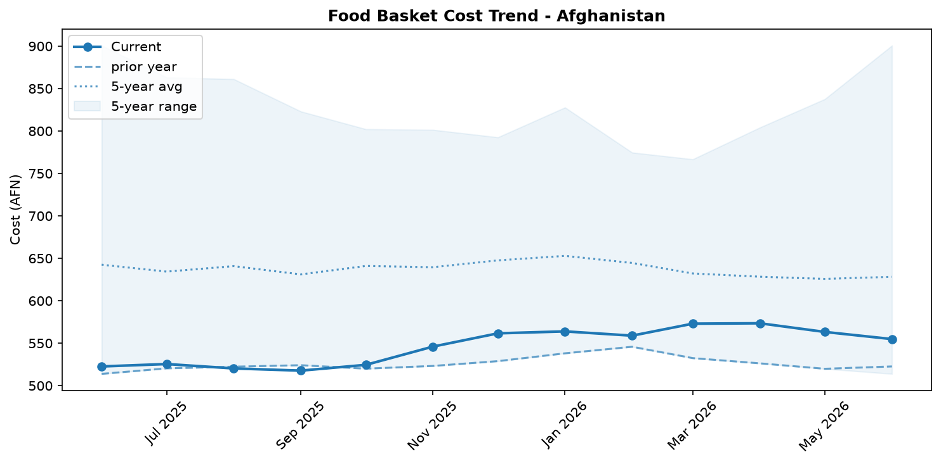
Food basket cost trend

Market Overview
Market conditions in June 2026 were characterized by a welcome but likely temporary reprieve in food prices, driven primarily by the ongoing seasonal harvest. The cost of the national food basket decreased by 1.5 percent month-on-month, with staple prices for wheat, rice, and sugar all falling. This downward trend was supported by adequate domestic commodity availability and a strong, stable Afghani (AFN), which has appreciated 8.8 percent year-on-year, helping to moderate the cost of imports. However, significant underlying pressures persist and threaten to reverse these gains. Rising diesel prices, up 2.1 percent in June, are increasing transportation costs and signal future inflationary pressure. Furthermore, the labor market remains under severe strain from the influx of 5.7 million returnees since late 2023, contributing to stagnant nominal wages that have fallen 2.8 percent over the past year. While households experienced short-term relief, their purchasing power remains severely eroded compared to last year, leaving them highly vulnerable to the expected resurgence of price inflation once the effects of the harvest season diminish.

Commodity Analysis
The June market saw a broad-based but fragile decrease in food commodity prices. The overall food basket cost fell 1.5 percent to AFN 554.86, though it remains 6.2 percent higher than a year ago. Key staples led the monthly decline, with wheat and high-quality rice prices falling by 4.0 percent and 3.2 percent, respectively, due to improved harvest supply. Sugar saw the most significant drop at 5.0 percent. This short-term relief, however, is overshadowed by severe year-on-year inflation, with rice and sugar prices remaining 31.2 percent and 21.9 percent higher, respectively, than in June 2025, highlighting persistent supply chain and import cost issues.
In stark contrast, the price of diesel fuel rose by 2.1 percent, a worrying trend that increases production and logistics costs for all goods. This upward pressure on fuel, partly linked to the Middle East crisis, threatens to pass through to consumer prices in the coming months.
For households, the terms of trade barely improved. Despite falling food prices, stagnant daily wages for casual labor meant purchasing power (in terms of wheat flour) improved by a marginal 0.8 percent. The year-on-year perspective is critical: with wages failing to keep pace with food inflation, real purchasing power has collapsed by 12.5 percent over the last twelve months, deepening household economic vulnerability.
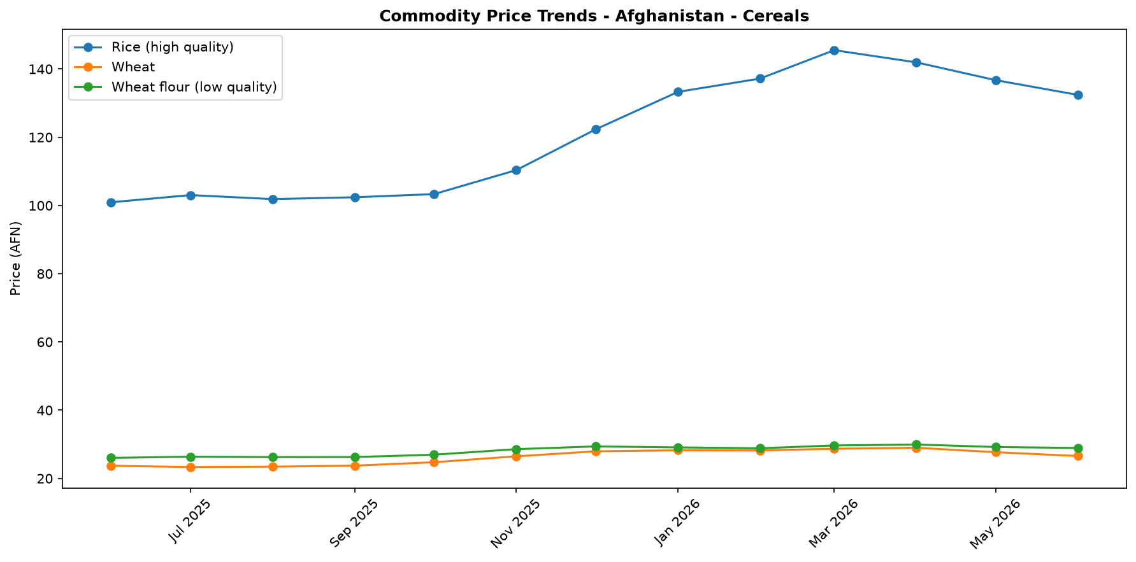
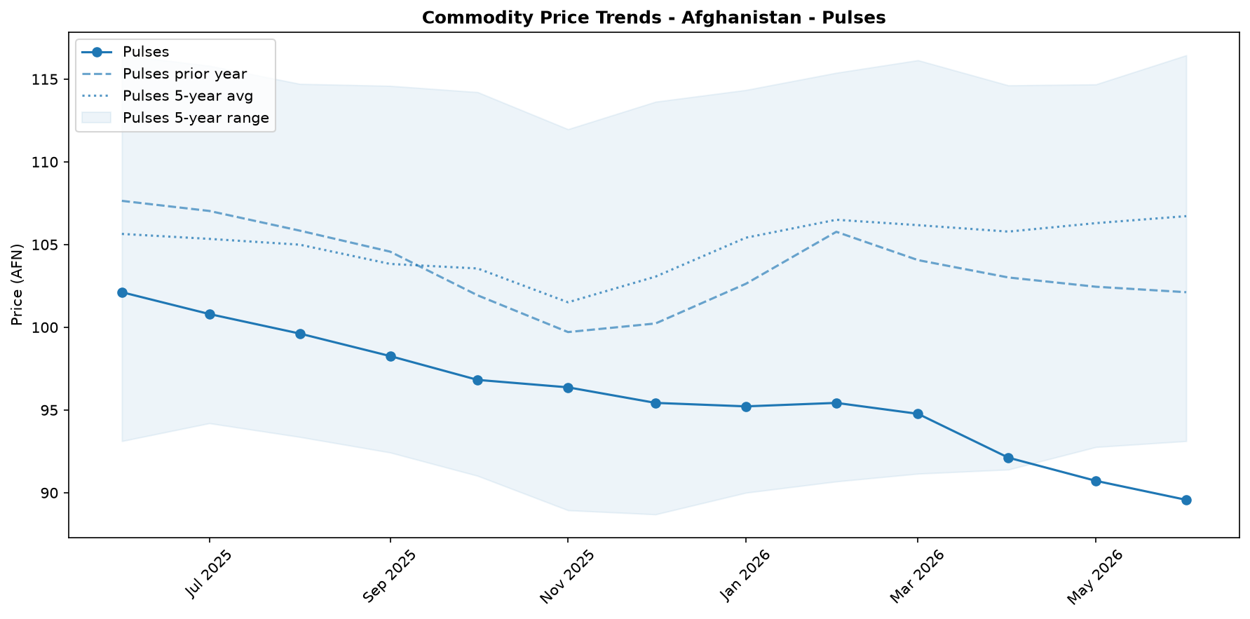
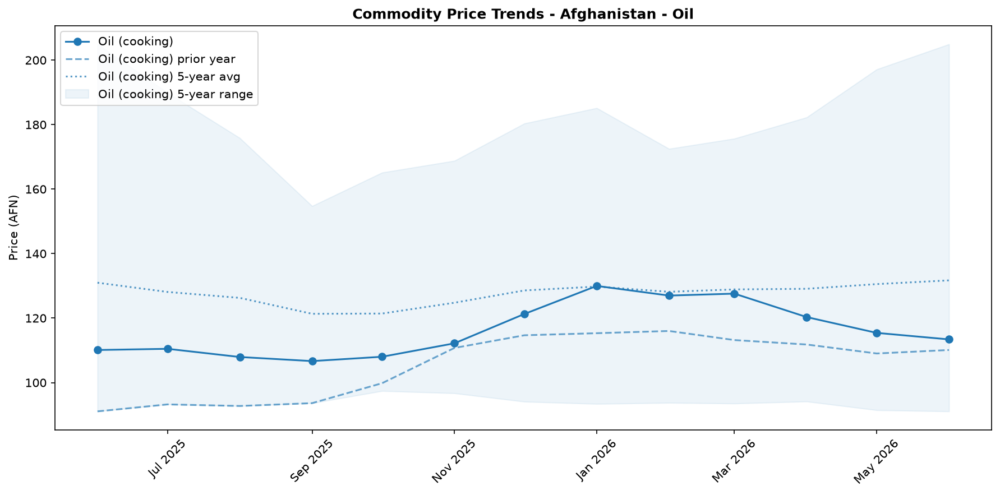
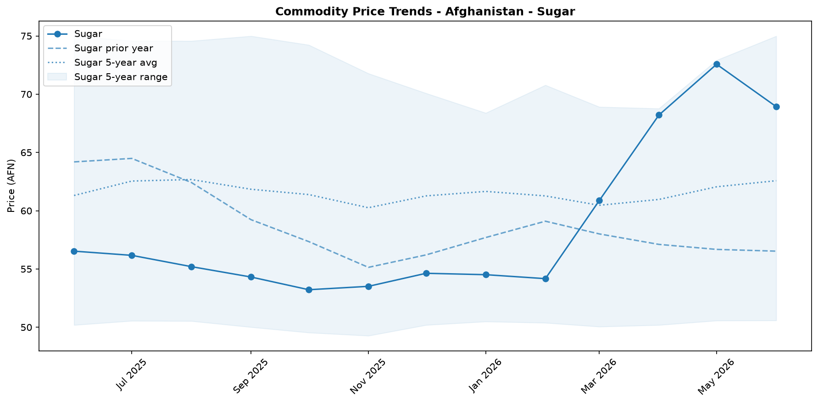
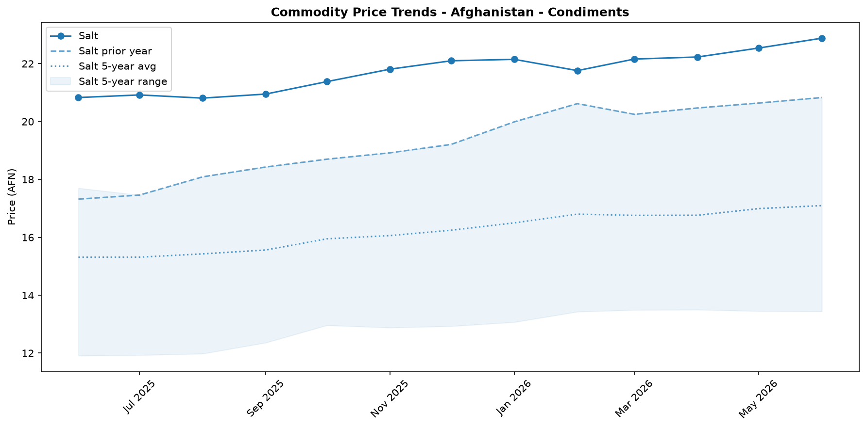

Regional Highlights
National price averages mask significant and growing regional disparities, primarily driven by logistical bottlenecks and shifting trade dynamics. The cost of fuel, a key driver of all other commodity prices, illustrates this fragmentation starkly. In June, the price of diesel in Nuristan (AFN 73.0/Litre) was 25.9 percent higher than in Nimroz (AFN 58.0/Litre). This wide variance suggests that recent disruptions at the Pakistan border are disproportionately affecting eastern and central regions, increasing logistics costs.
Conversely, provinces in the west and south, such as Nimroz, appear to be benefiting from the strategic shift in trade routes. With an estimated 60 percent of trade volume now transiting through Iran, these regions have better access to imported goods and consequently lower prices. This divergence creates distinct economic realities within the country, where households in logistically isolated areas face a much higher cost of living and greater vulnerability to supply shocks. These regional price spreads are a critical indicator of the fragility of Afghanistan's internal supply chains.
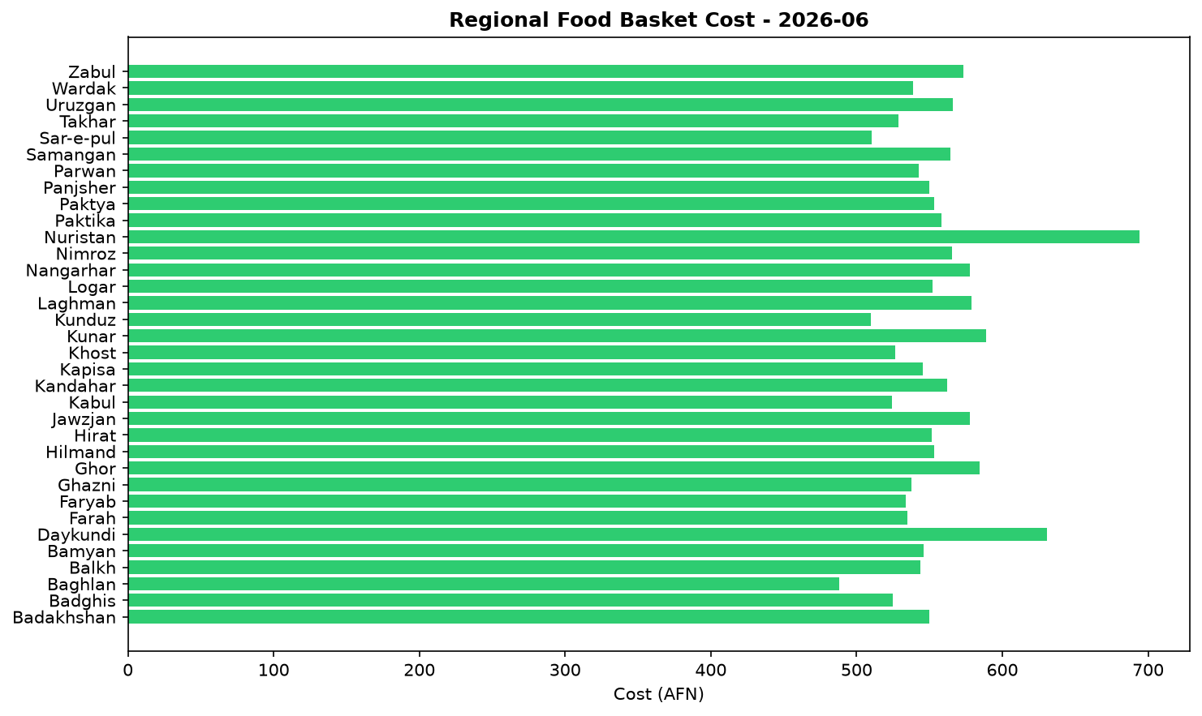

Exchange Rate Analysis
The Afghan Afghani (AFN) remained stable, trading at 64.0 AFN per US dollar. Month-on-month, the currency experienced a marginal depreciation of 0.14 percent, suggesting a negligible immediate impact on the cost of imports. From a longer-term perspective, however, the AFN has appreciated significantly by 8.84 percent compared to the same period last year, indicating a substantial strengthening over the past twelve months. This year-on-year appreciation, combined with the recent stability, helps to contain the local prices of essential imported commodities. It exerts downward pressure on the cost of items like wheat, rice, cooking oil, and fuel, which is beneficial for household purchasing power and food security.

Fuel & Energy
The national average price of diesel increased by 2.1 percent in June 2026 to AFN 65.44 per litre, standing 4.4 percent higher than the same time last year. This increase is consistent with pressure from supply and logistics constraints, which can impact import costs and internal distribution. Higher fuel costs translate directly into increased transportation expenses, putting upward pressure on food prices and threatening to erode the benefits of recent seasonal price decreases for staples. This pressure is uneven across the country, with diesel prices in Nuristan over 25 percent higher than in Nimroz.
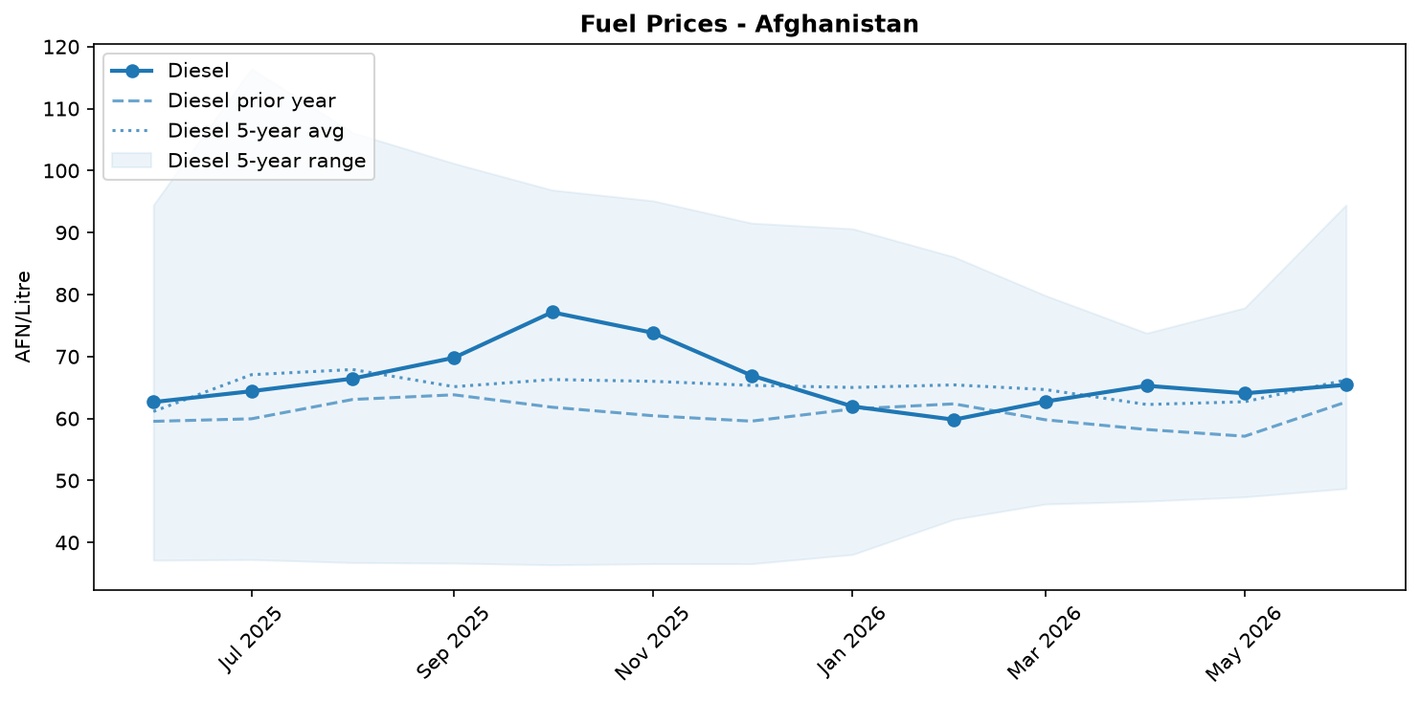
Fuel retail price trend

Labour Market
In June, the daily wage for casual unskilled labour decreased slightly by 0.2 percent to AFN 304.41, which is 2.8 percent lower than a year ago; the skilled wage also saw a minor monthly decline of 0.3 percent. Despite this, the purchasing power of a daily wage improved slightly by 0.8 percent, now equivalent to 10.53 kg of low-quality wheat flour, though it remains 12.6 percent below last year's level. This marginal monthly gain is consistent with seasonally lower staple food prices from the ongoing harvest, which offset the stagnant nominal wages.
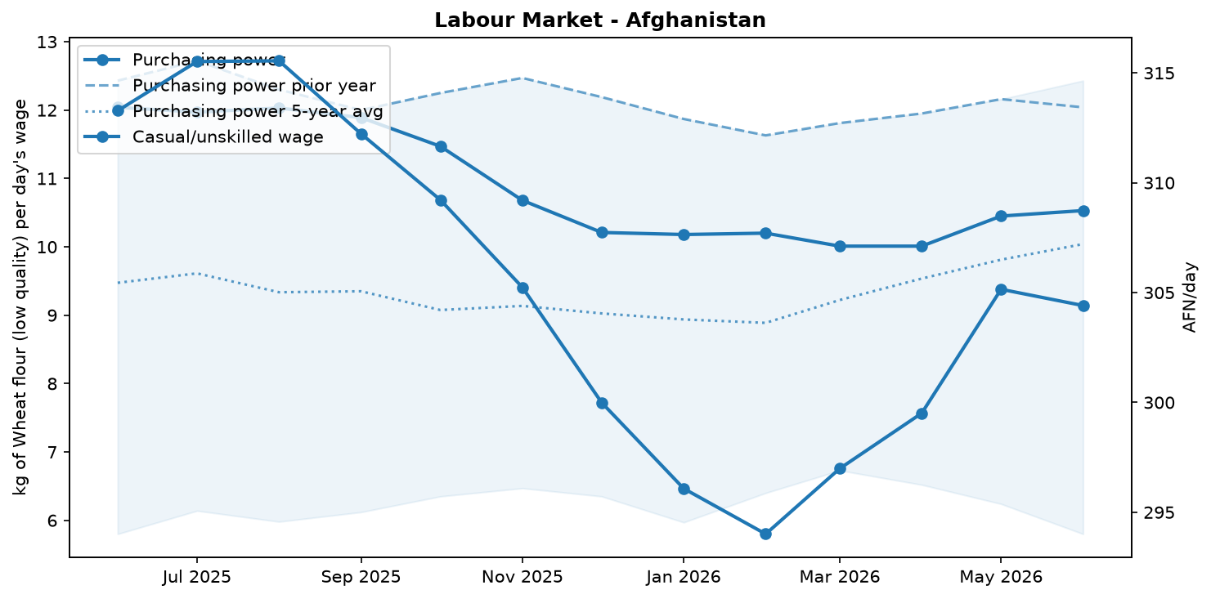
Labour market trend

References
- [rw_4218589] ReliefWeb (2026-06-30) Forced back and left behind: Conditions for urban returnees and the urgent need for local integration in Afghanistan
https://reliefweb.int/node/4218589
- [rw_4218516] ReliefWeb (2026-06-30) Afghanistan: Weekly Market Report: Issue 301: Week 4 – June 2026
https://reliefweb.int/node/4218516
- [rw_4218513] ReliefWeb (2026-06-30) World Vision Afghanistan: Community Validation Assessment of Evolving Needs and Priorities: Validation of the 2025 Multi-Sector Needs Assessment (MSNA) - Herat | Ghor | Badghis | Faryab Province
https://reliefweb.int/node/4218513
- [rw_4218118] ReliefWeb (2026-06-26) Food security under pressure: Impacts of the Middle East Crisis and Pakistan Conflict on Afghanistan (June 2026)
https://reliefweb.int/node/4218118
- [rw_4218068] ReliefWeb (2026-06-26) Afghanistan: Countrywide Weekly Market Price Bulletin, Issue 300: Week 3 – June 2026
https://reliefweb.int/node/4218068
- [rw_4217984] ReliefWeb (2026-06-25) Afghanistan: Alarming increase in admissions of severely malnourished children in south
https://reliefweb.int/node/4217984
- [rw_4217864] ReliefWeb (2026-06-25) Regional Middle East Logistics Coordination - 3 Months of Coordination (March - June 2026)
https://reliefweb.int/node/4217864
- [rw_4217615] ReliefWeb (2026-06-24) UNHCR Afghanistan Situation Regional Update May 2026
https://reliefweb.int/node/4217615
- [rw_4217254] ReliefWeb (2026-06-22) Data for Afghanistan: Afghanistan Consumer Price Index (CPI) Report — April 2026
https://reliefweb.int/node/4217254
- [rw_4217179] ReliefWeb (2026-06-22) Afghanistan: Weekly Market Report: Issue 300: Week 3 – June 2026
https://reliefweb.int/node/4217179
- [seerist_1028928] Seerist (2026-06-10) Military co-operation between Taliban, Russia unlikely to significantly boost Taliban’s capabilities
- [seerist_1028903] Seerist (2026-06-09) Sovereign risk remains EXTREME despite improvement in tax revenues
- [seerist_1028629] Seerist (2026-05-20) New law on distribution of state land underscores EXTREME regulatory risk
- [seerist_1028557] Seerist (2026-05-15) Clashes over gold mine, Taliban’s poppy destruction policy underscore EXTREME security risk
- [seerist_1028494] Seerist (2026-05-12) Uptick in Pakistan-Afghan Taliban hostilities likely following complex attack in Khyber Pakhtunkhwa

